Order Form Waveski Custom Pro Model

Contact : Virgile Humbert
contact@solamanzi.com (+ 33) 6 58 87 19 20

Order's date : …...../.........../..........

- THE RIDER :

Name : .....................
Surname : .........................
Age : …...........
Phone : …...................
Email : ….............................
Adress : …...................................................................................
Rider's height: ….....................
Rider's weight: ......................
Years of experience: …...........
Preferred wave type & size : ….............
Curent waveski, mesurement, model... : ........................................................................................................................................

- THE BOARD:

Virgile Humbert PRO MODEL:

Based on Virgile Humbert’s favorite board, this range is very flexible and allow to design from the fish tail until the gun. The 3D conception is made by Virgile Humbert and a proposition of design in 3D and 2D will be made within 3 weeks maximum for your validation.

VERY IMPORTANT ! :
Mesurement on your actual board like on the draw – Footstraps position :.......................

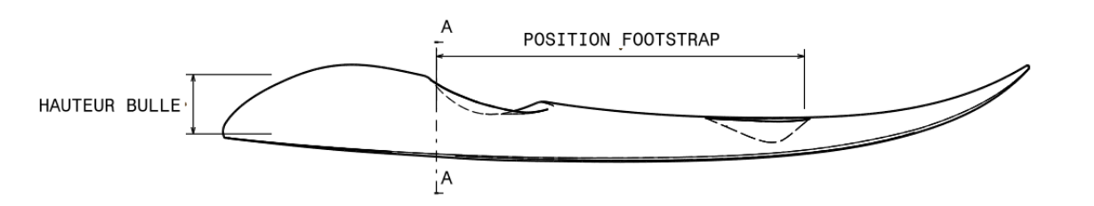

DESIGN OF THE PRO MODEL:
Design without extra cost : bottom deck in clear carbon looking, white on the deck with carbon reinforcement strips

- Options (extra cost):
One color on the top : ........................................................50 USD
Different design, ask a quotation with filling the drawing attached:

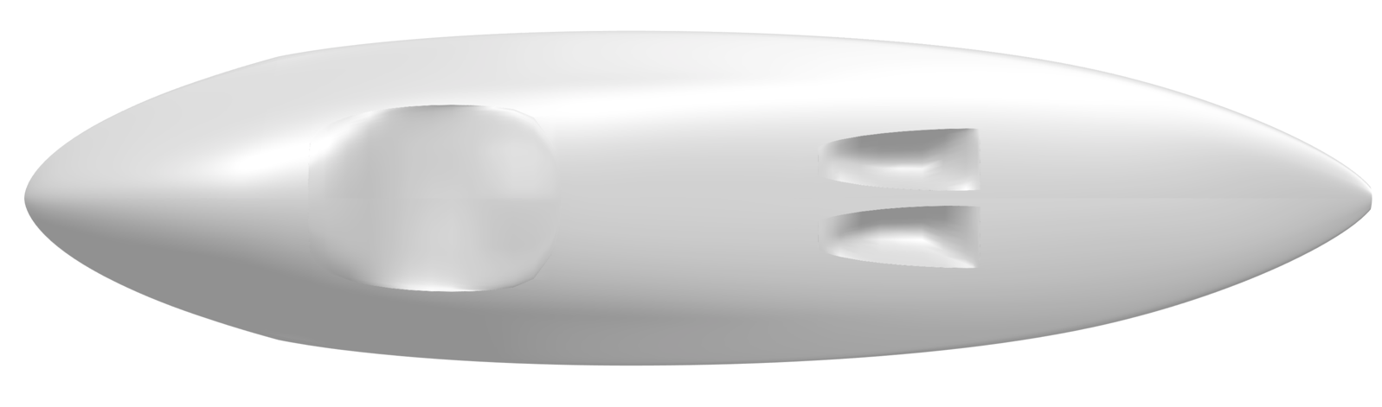

GEAR :
- Included in the Promodel price
SEAT : black / grey
SEAT BELT : Black/White or Black (Pro Model)
FOOTSTRAPS : Black/White or Black (Pro Model)

- Options: Seat EXTRA pads ….........................................14 USD
Pads élargisseurs de ceinture / seatbelt extender …......... 25 USD

FINS SETUP:
- TRI FINS : 2 FCS II on side boxes + FCS II central box included in the price
- QUAD FINS OPTION : 4 FCS II boxes on sides + un FCS II central …. 50 USD

Event goretex screw: 15 USD

Central lift handle as Stand Up Paddle….. 50 USD

RATE :
Virgile Humbert pro model with Solamanzi accessories (seat pad, seat belt , footstraps) : 1900 USD

Designation | Total
Waveski Pro Model | $
Additional cost of the design | $
Extra cost or options on gear | $
Extra cost or options on fins | $
Extra cost or options on plugs | $
Shipping on quotation | $
TOTAL | $

Delivery at INFINITY SURFSHOP in Dana Point California
Or option delivery on quotation

Signature de Virgile Humbert :

Signature du client :

